# Okasha - Use Cases Documentation

## Member: Okasha

**Assigned Use Cases:** Accept Supervision, Review Proposal

**UC-06: Accept Supervision**

| **Attribute** | **Description** |
| --- | --- |
| Use Case ID | UC-06 |
| Use Case Name | Accept Supervision |
| Actor | Supervisor |
| Description | Supervisor reviews and accepts or declines student supervision requests for FYP projects |
| Preconditions | Supervisor is logged in, Student proposals are submitted, Coordinator has assigned supervision requests |
| Postconditions | Supervision status is updated, Student is notified, Supervisor workload is updated |
| Priority | High |
| Frequency of Use | Multiple times per semester |
| Normal Flow | 1. Supervisor logs into system  2. System displays supervisor dashboard  3. Supervisor clicks on "Supervision Requests" section  4. System displays list of pending supervision requests  5. Supervisor selects a specific request  6. System displays student profile and project proposal  7. Supervisor reviews student academic record  8. Supervisor analyzes project proposal details  9. Supervisor checks current supervision workload  10. Supervisor makes decision (Accept/Decline)  11. Supervisor provides reason/comments  12. System validates supervisor capacity limits  13. System updates supervision status  14. System sends notification to student  15. System updates supervisor workload counter  16. System logs supervision decision  17. System displays confirmation message |
| Alternative Flows | A1: Accept with Conditions  - At step 10, supervisor accepts with modifications  - Supervisor specifies required changes  - System sets status to "Conditional Accept"  - Student must address conditions  - Resume at step 13  A2: Request More Information  - At step 10, supervisor requests additional details  - System sets status to "Information Requested"  - Student provides additional information  - Supervisor reviews again  - Resume at step 8  A3: Defer Decision  - At step 10, supervisor defers decision  - Supervisor sets reminder date  - System schedules follow-up notification  - Resume at step 5 on reminder date |
| Exception Flows | E1: Supervision Limit Exceeded  - At step 12, if supervisor at maximum capacity  - System displays capacity limit message  - Supervisor cannot accept more students  - System suggests alternative supervisors  E2: Request Already Processed  - If another supervisor already accepted student  - System displays "Request no longer available"  - Supervisor returned to requests list  E3: Student Withdrew Request  - If student cancelled supervision request  - System displays "Request withdrawn"  - Request removed from supervisor's list |
| Business Rules | BR-01: Supervisor can supervise maximum 8 students simultaneously  BR-02: Response required within 7 days of request  BR-03: Reasons must be provided for declined requests  BR-04: Conditional acceptance requires specific conditions  BR-05: Supervision decisions are final once accepted |
| Special Requirements | SR-01: Email notifications for all decisions  SR-02: Deadline reminders for pending requests  SR-03: Workload tracking and capacity warnings  SR-04: Mobile-friendly interface for quick decisions |
| Technology Variations | Push notifications for mobile app |
| Frequency | 20-50 supervision decisions per semester |
| Open Issues | Integration with faculty workload management system |

## UC-07: Review Proposal

| Attribute | Description |
| --- | --- |
| Use Case ID | UC-07 |
| Use Case Name | Review Proposal |
| Actor | FYP Coordinator, Supervisor |
| Description | Coordinator and supervisors review submitted student proposals for technical feasibility, academic merit, and approval |
| Preconditions | User is logged in with reviewer privileges, Proposals are submitted, Review assignments are made |
| Postconditions | Proposal status is updated, Feedback is provided, Student is notified of decision |
| Priority | High |
| Frequency of Use | Multiple times per semester |
| Normal Flow | 1. Reviewer logs into system  2. System displays reviewer dashboard  3. Reviewer navigates to "Proposals for Review"  4. System displays list of assigned proposals  5. Reviewer selects proposal to review  6. System displays complete proposal details  7. Reviewer evaluates proposal against criteria  8. Reviewer checks technical feasibility  9. Reviewer assesses academic merit and novelty  10. Reviewer verifies resource requirements  11. Reviewer provides detailed feedback  12. Reviewer assigns scores for each criterion  13. Reviewer makes final decision (Approve/Reject/Revise)  14. System validates all review fields completed  15. System saves review and updates proposal status  16. System sends notification to student  17. System notifies coordinator of review completion  18. System displays review confirmation |
| Alternative Flows | A1: Request Major Revisions  - At step 13, reviewer requests major changes  - Reviewer specifies required modifications  - System sets status to "Revision Required"  - Student must resubmit revised proposal  - Resume normal flow for revised proposal  A2: Request Minor Revisions<  - At step 13, reviewer requests minor changes  - Reviewer specifies small modifications needed  - System sets status to "Minor Revision Required"  - Student can update without resubmission  - Resume at step 14  A3: Conditional Approval  - At step 13, reviewer gives conditional approval  - Reviewer lists conditions to be met  - System sets status to "Conditionally Approved"  - Student must fulfill conditions before proceeding |
| Exception Flows | E1: Proposal Plagiarism Detected  - At step 8, if plagiarism is detected  - System flags proposal for investigation  - Reviewer escalates to coordinator  - Disciplinary action may be initiated  E2: Incomplete Review Submission  - At step 14, if required fields missing  - System highlights incomplete sections  - Reviewer must complete all sections  - Resume at step 14  E3: Review Deadline Exceeded  - If review not completed within deadline  - System sends overdue notifications  - Coordinator reassigns to another reviewer |
| Business Rules | BR-01: All proposals must be reviewed within 10 working days  BR-02: Minimum score thresholds must be met for approval  BR-03: Detailed feedback required for all rejected proposals  BR-04: Two reviewers required for borderline cases  BR-05: Plagiarism check mandatory before approval |
| Special Requirements | SR-01: Integrated plagiarism detection tool  SR-02: Standardized scoring rubric  SR-03: Blind review option for fairness  SR-04: Review progress tracking dashboard |
| Technology Variations | PDF annotation tools for detailed feedback |
| Frequency | 100-200 proposal reviews per semester |
| Open Issues | Implementation of blind review mechanism |

## Collaboration Diagrams

## Accept Supervision Collaboration Diagram:

## C:\Users\ukasha arif\Downloads\1ok.drawio.png

1. **Review Proposal Collaboration Diagram:**

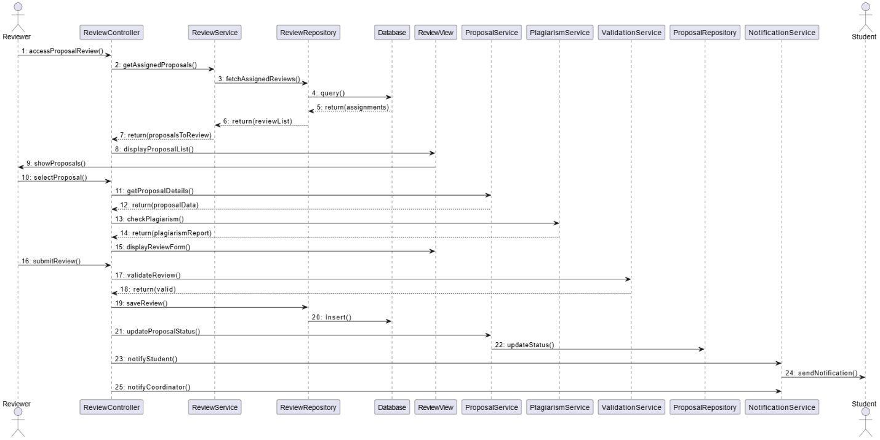

## System Sequence Diagrams

1. **Accept Supervision System Sequence Diagram:**

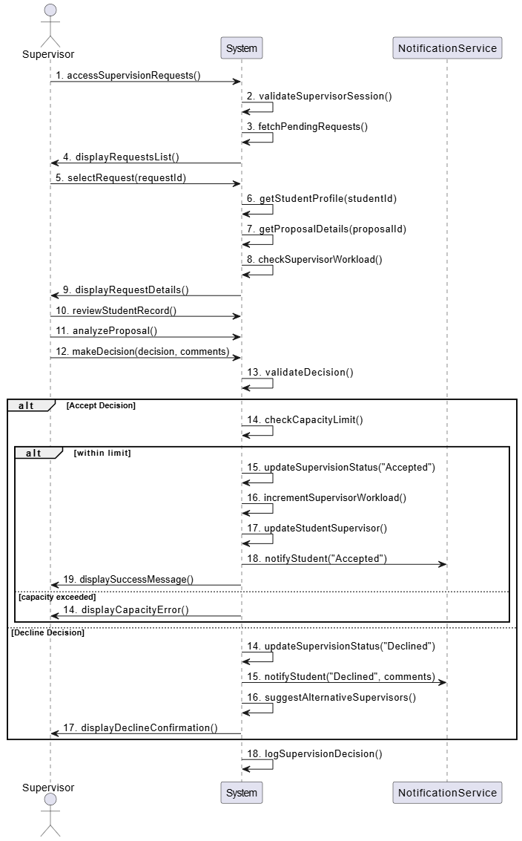

1. **Review Proposal System Sequence Diagram**:

